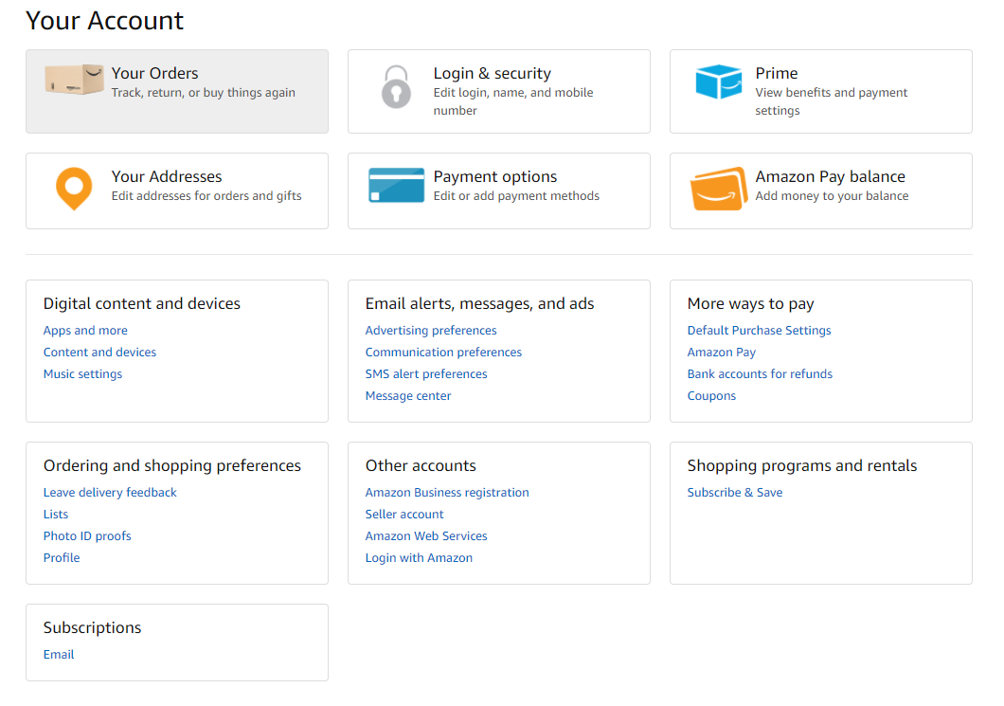

**In Your account click“Your Orders”,**

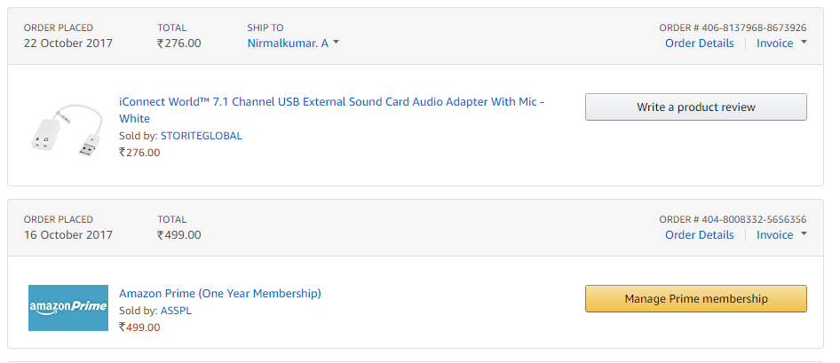

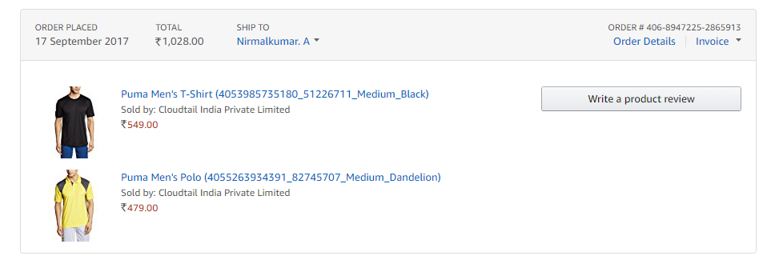

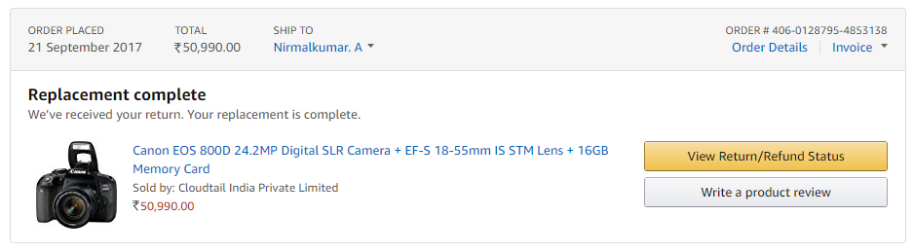

Scrap the following for all the years(Order history is displayed Yearwise)

1. Order #, Order placed date(‘ORDER PLACED’ field), Order delivery status(If replacement or returned, it will be displayed in Bold), Order value(‘TOTAL’ field), Shipping name(‘SHIP TO’ field), phone no(Hover over “SHIP TO” Field)
2. If there are multiple products within an order- >Order #, Order Delivery Date (‘ORDER PLACED’ field), Product Prices (against each product)
3. If Cancelled, then Refund Description, Refund status

Click on Order details

Comment:

1. Need to scrap product category.
2. Add the quantity of total orders and of total product items.
3. Need to know the times of cancellation, put “Refund Description, Refund Status (if cancelled)” at low priority.

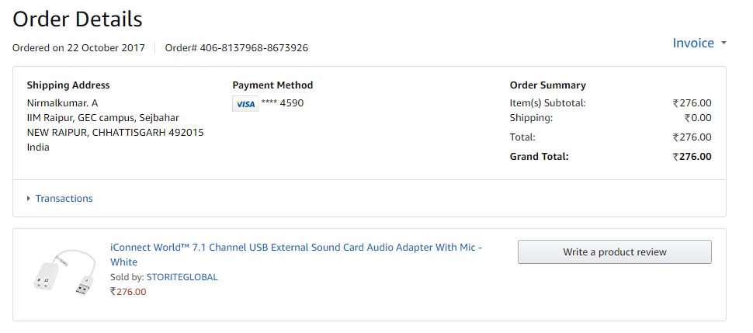

Scrap the following for each order

1. Order #
2. Order date
3. shipping address
4. Payment Method(Card type(Visa, Master card etc) and Card number ending with)

Comment: Add 5. Name for each order.

**In Your Account, Click “Login and security”**

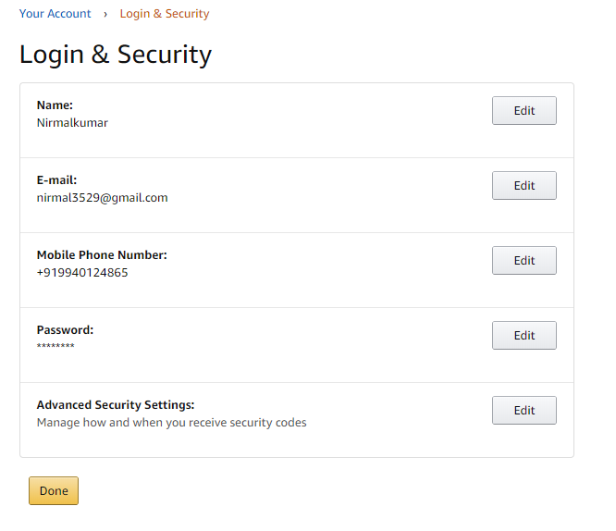

Scrap the following

1. Name
2. E-mail
3. Phone number

**In Your Account, Click “Prime”**

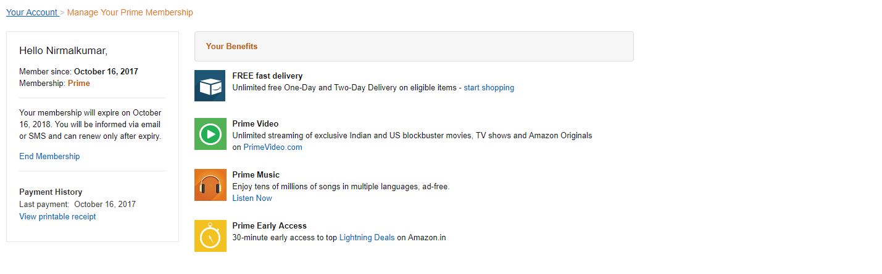

Scrap the following details

1. Member since
2. Expiry Date
3. Payment history

**In Your Account, Click “Your Addresses”**

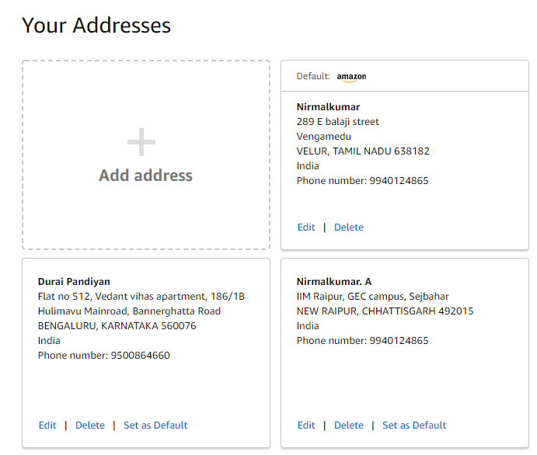

Scrap the following for each address

1. Name
2. Address
3. Pincode
4. Phone number
5. Default flag marked for the address

**In Your Account, Click “Payment Options”**

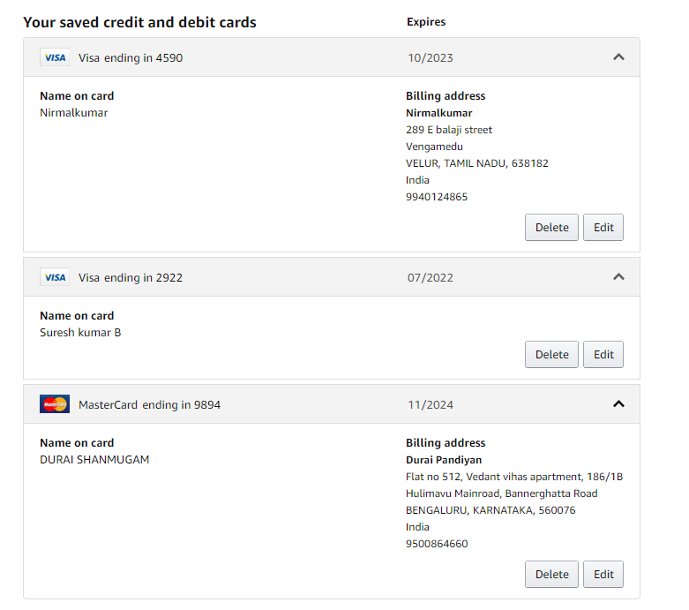

Scrap the following

1. Name on card
2. Card Type (Visa/Master/Rupay based on the icon)
3. Card Expiry Date

**In Your Account, Click “Amazon Pay Balance”**

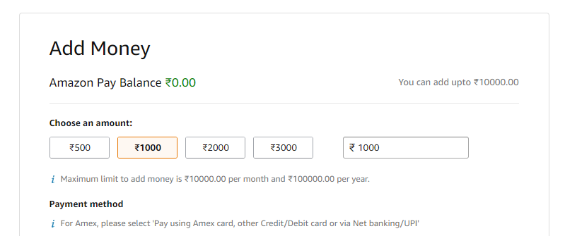

Scrap “Amazon Pay Balance” (If the Balance is not 0, need to check if there is something else that can be scrapped like history of transactions)



Click on <your account>’s Amazon.in URL.



Click on Your Profile URL.

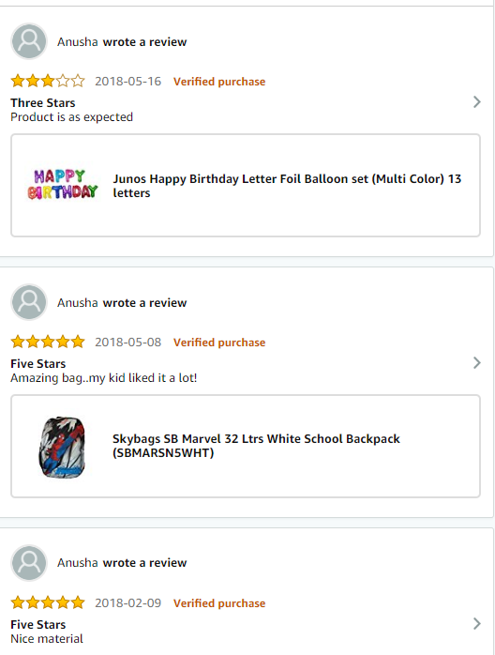

Scrap the following:

* Total Review count
* Review rating
* Review date
* Purchase type

帐号信息:

**vikram**

9597954836

abc@123

**vineeth**

9003367232

abc@123

**Mridu**

8562851868

abc@123

**Adhitya**

[v.adhitya07@gmail.com](mailto:v.adhitya07@gmail.com)

Abc@123